**IBM WATSON PLATFORM**

|  |  |
| --- | --- |
| Team Id | PNT2022TMID16026 |
| Project Name | Smart Farmer – IOT Enabled Smart Farming Application |

**Step 1:** Log in to your registered Id.

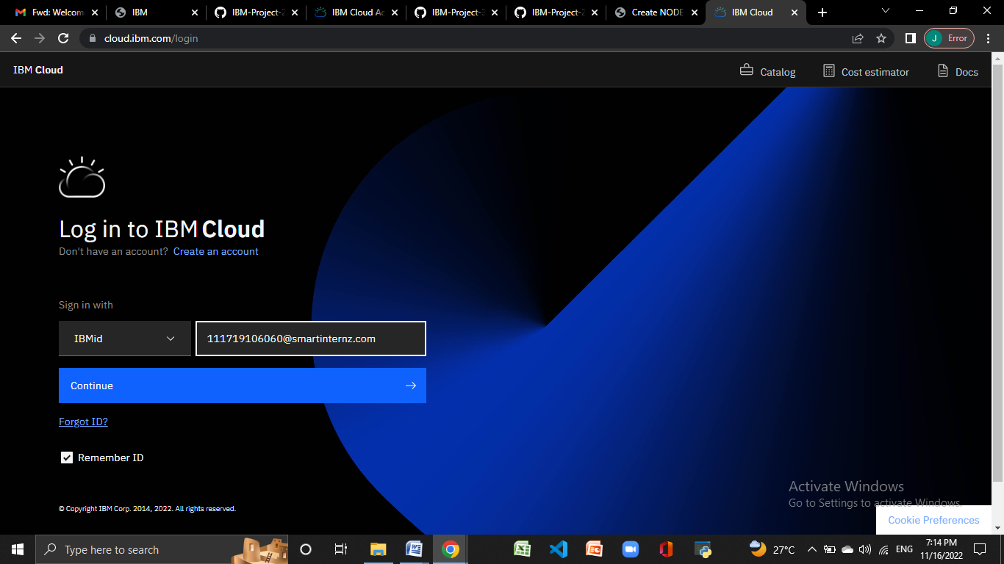

**Step 2:** click catalog where you find the services and internet of thing you can select and make location as London

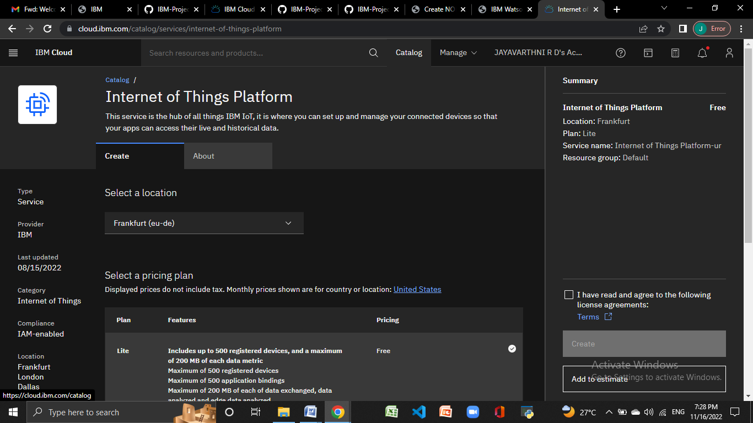

**Step 3:** click create and the launch tab get open, then click launch

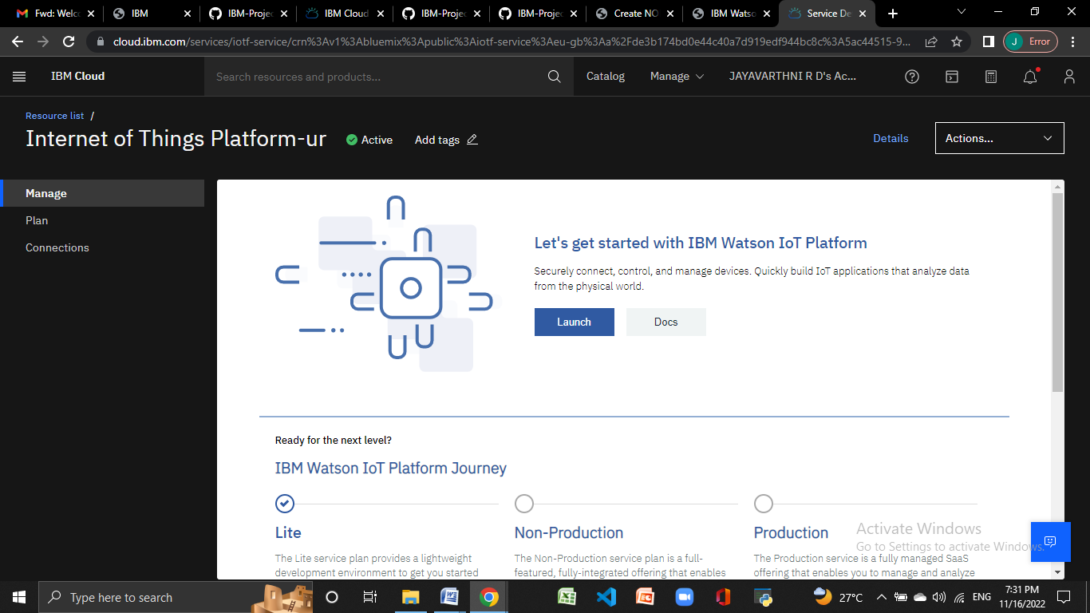

**Step 4:** It redirect you to IBM WATSON platform where you need to click sign in.

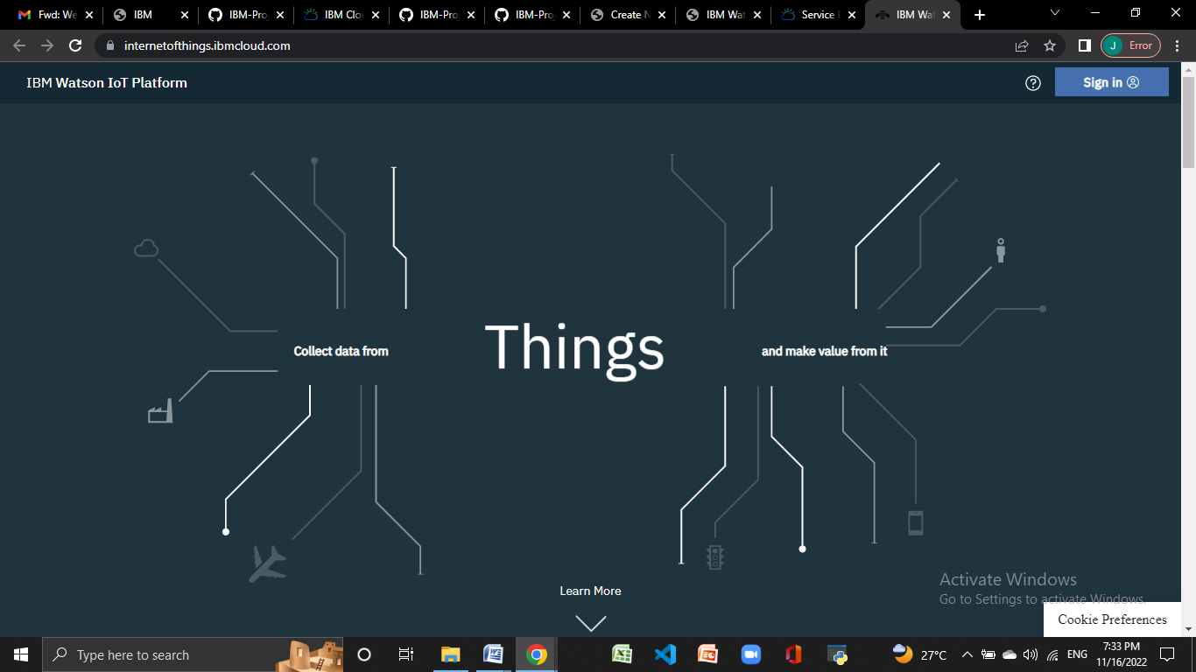

**Step 5:** you need to log in IBM ID

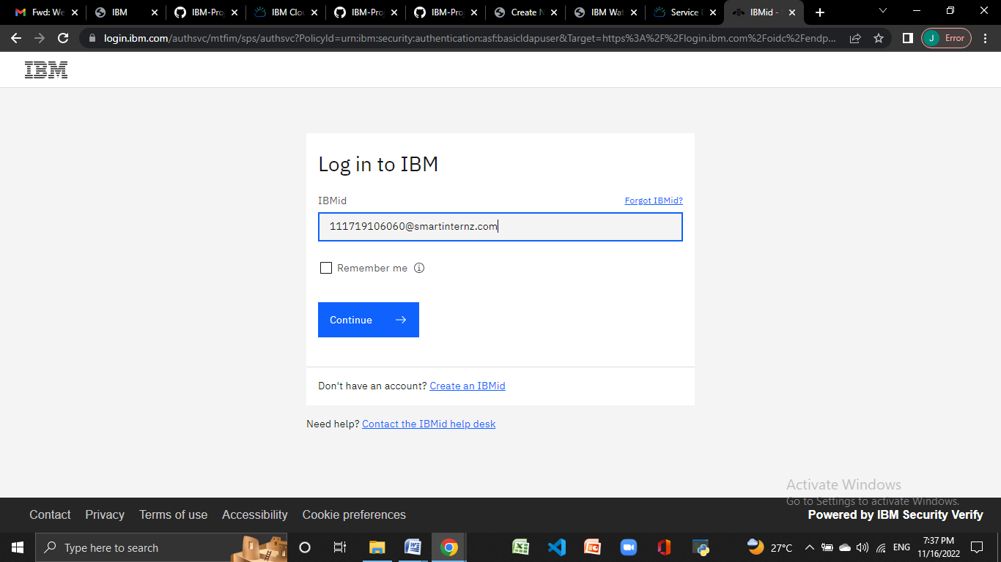

**Step 6:** where you find this tab which is used to add device, app, member ,usage , security can be worked

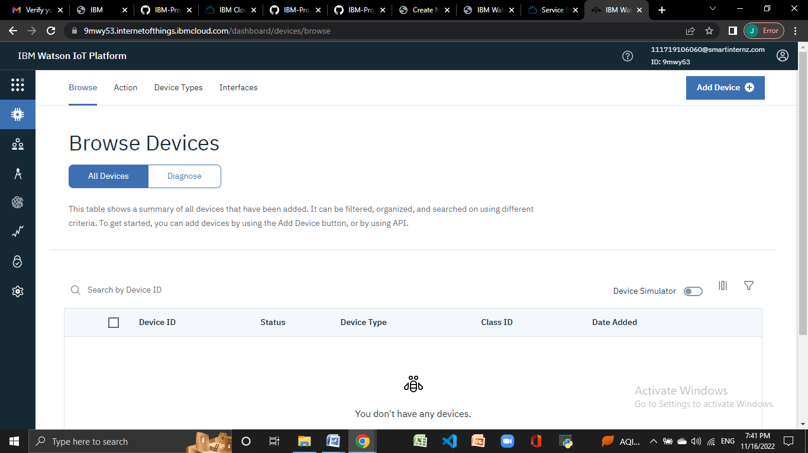

**Step 7:** check boards for risk and security overview card , it uses for graphical representation boards

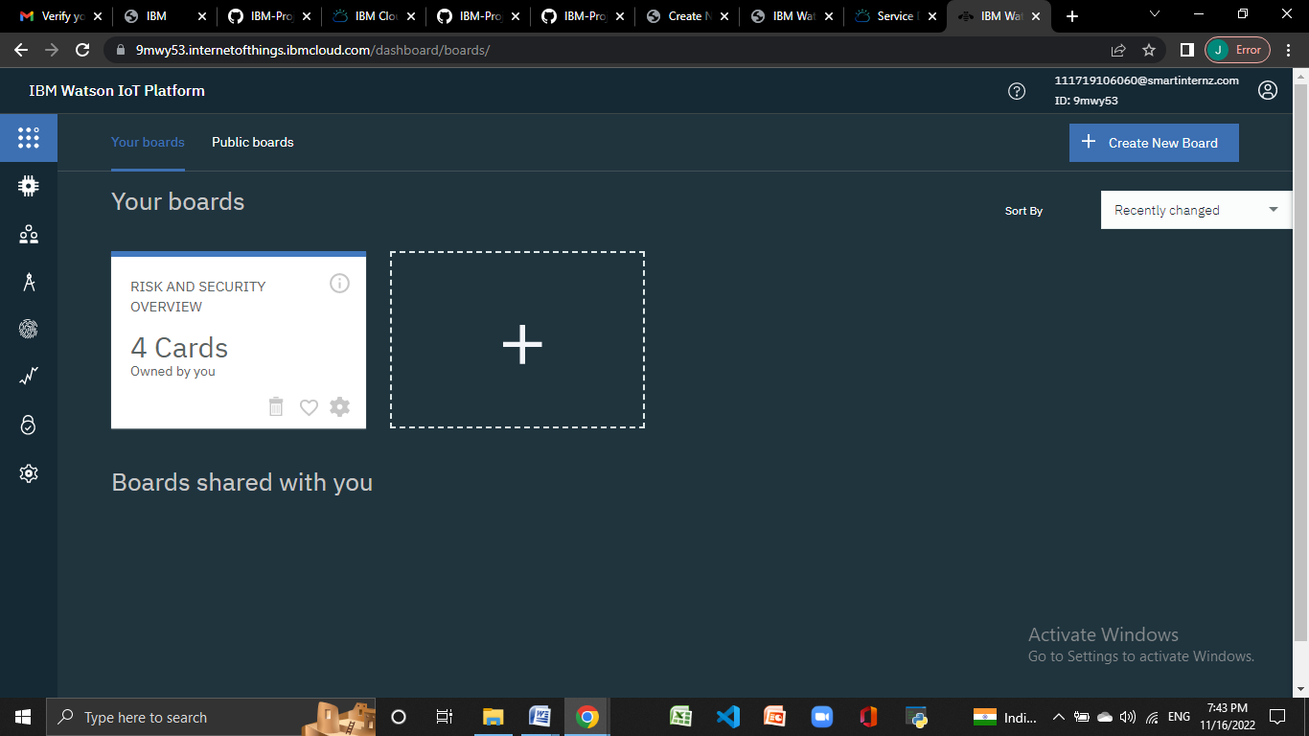

**Step 8:** after clicking create a new device / add device you can choose an device type and device id and complete the following information to create a device

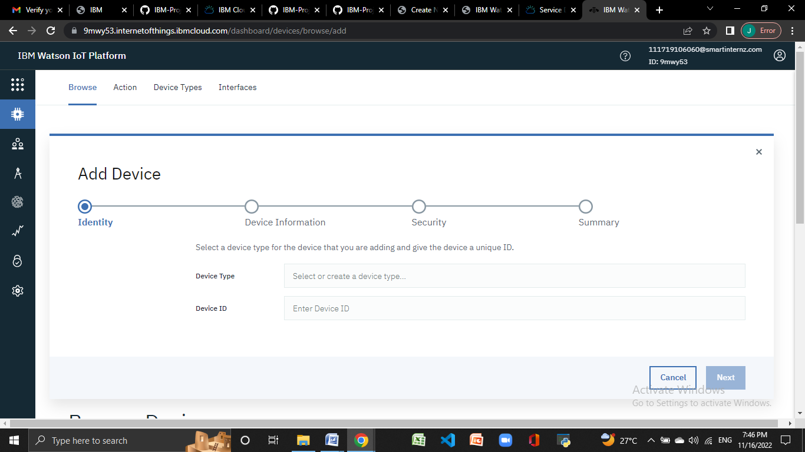

**Step 9:** created a device of NodeMCU

